2016 data

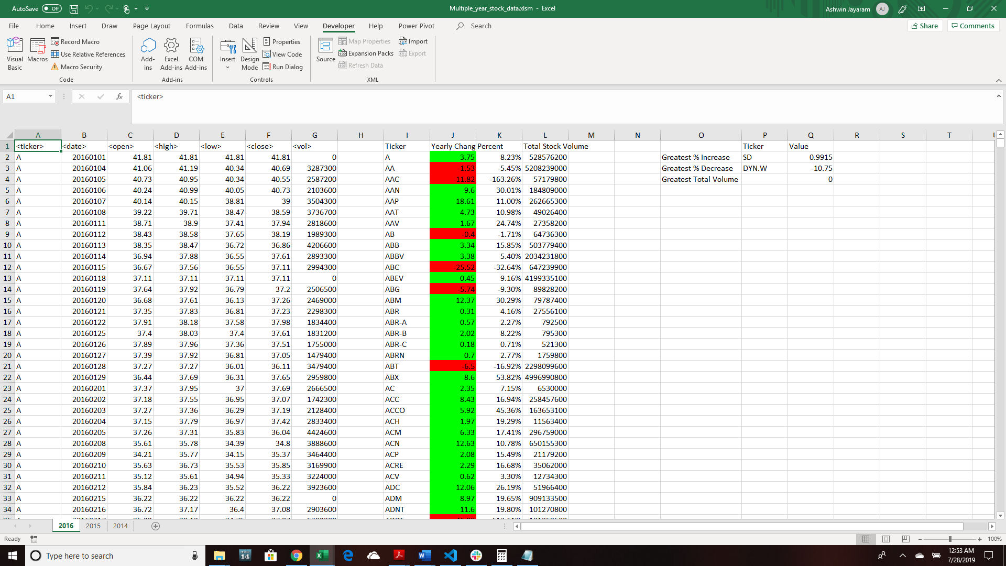

2015 Data

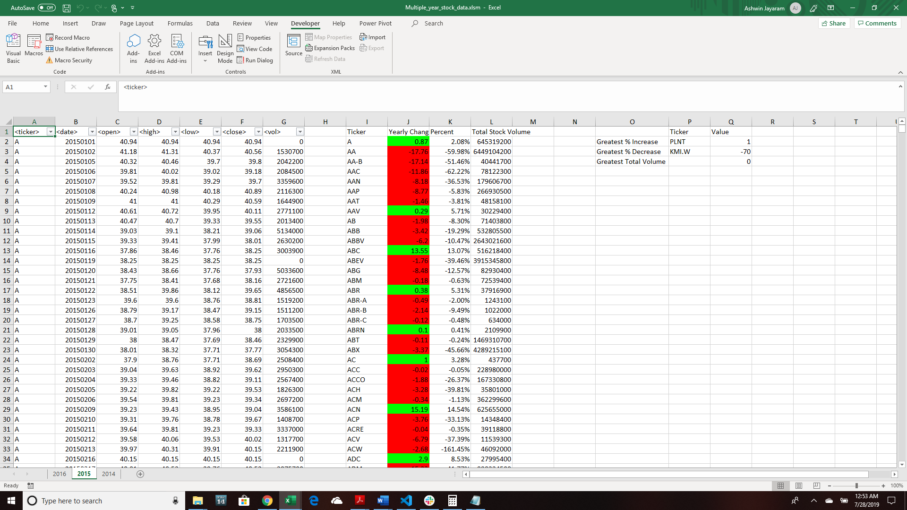

The greatest % is a misleading because PLNT had no values for many months and it got the value 1 from (closing price – 0)/closing price

I also don’t understand why the percentage calculation works for most of the items on column K, but for KMI.W there is this amount. I’m not sure where that number came from

2014 Data

